# SUREBANK PROJECT

YML files are most commonly used as configuration files, which define a program or application’s settings. If a program uses a YML file as a settings file, you can edit the program’s settings by opening and editing the YML file in a text or source code editor. Most settings-related YML files include comments that explain how the file can be used to adjust a program’s settings.

# JPA🡺Java Persistence API

### Persistence: Persistence simply means to Store Permanently(kalici olarak). In JAVA we work with Objects and try to store Object’s values into database(RDBMS mostly). JPA provides implementation for Object Relation Mapping(ORM),so that we can directly store Object into Database as a new Tuple.

### The Java ORM standard for storing, accessing, and managing Java objects in a relational database.

* Create all the packages under com.bank.sure because main method is in this package

### 🡺Why do I extend to Interface Serializable

It is done to get permit for serialization. It is a marker interface with no method. I am allowed to use the instances of the classes which also implements this interface. As as result it is a “must” for serialization

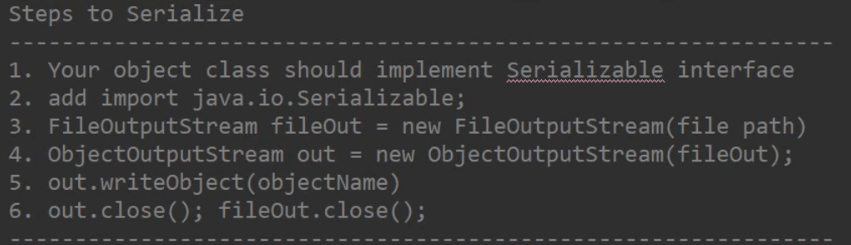

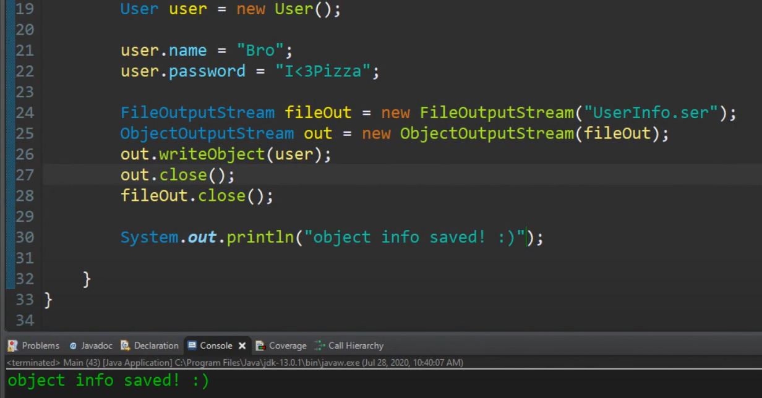

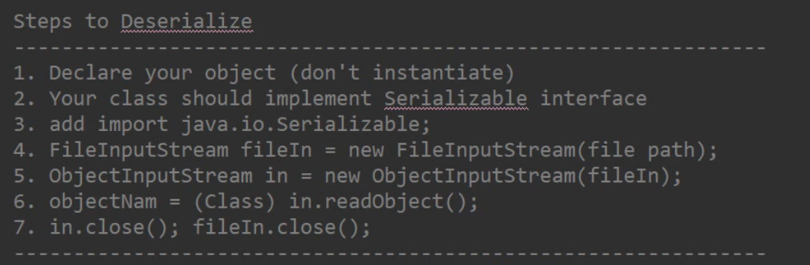

# 

#### Dependency Injection:

**groupId:** This element indicates the unique identifier of the organization or group that created the project. The groupId is one of the key identifiers of a project and is typically based on the fully qualified domain name of your organization. For example org. apache. maven.

**artifactId:** is the name of the jar without version. If you created it, then you can choose whatever name you want with lowercase letters and no strange symbols. If it’s a third party jar, you have to take the name of the jar as it’s distributed.

Jpa Repository 🡺

JpaRepository is a JPA (Java Persistence API) specific extension of Repository. It contains the full API of CrudRepository and PagingAndSortingRepository. So it contains API for basic CRUD operations and also API for pagination and sorting.

JPA is a specification a common language. With JPA you can switch from one tool to another. E.g hibernate to iBatis ..here ibatis or hibernate is implementation JPA is specification

We are using ORM so we need a class which represents a table.

